Chapter 9, Solution 47.

In the circuit shown in Fig. 9.54, determine the value of i_{s}(t).

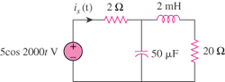

Figure 9.54
For Prob. 9.47.

Solution

First, we convert the circuit into the frequency domain.

2 Ω

5∠0˚

+
−

20 Ω

I_{x}

j4

-j10

i_{s}(t) = 460.7cos(2000t +52.63˚) mA

